Transistor Mixer

This is a transistor audio mixer. The load is 100 kohms. Thus you should not connect this circuit to the speaker which is typically only 8 ohm impedance. This circuit needs to be connected to a power amplifier and some kind of audio input with at least 10 kohms input impedance. Some Line In inputs have impedance above 10 kohms.

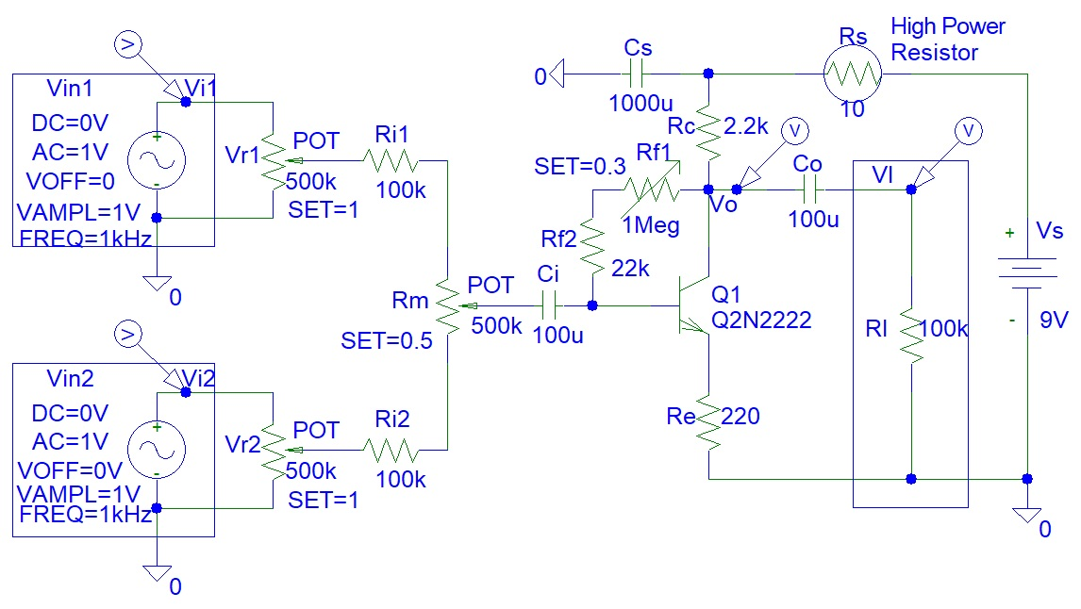
Figure 1: BJT Transistor Mixer

You also have to consider the maximum input voltage that the audio input can dissipate. Initially the Co capacitor is short circuit and if Rf1 is at maximum resistance setting, the voltage Vo will equal to Vl and will be 9 V DC, which could be above the maximum allowed input voltage for the audio output that you might choose to use. Thus you might want to reduce the power supply to only 1.5 V. However, smaller power supply voltages will cause output saturation and clipping if the inputs are very high.

Mixers can be made with operational amplifiers. Transistors are usually used to obtain a non linear amplification to create unique audio distortions and sound effects. One example of such transistors are FETs (Field Effect Transistors). The circuit in Figure 1 is a linear mixer because a linear Bipolar Junction Transistor (BJT) is used. It is easier to connect than an operational amplifier and can work on 1.5 V power supply, unlike an operational amplifier that will require at least 9 V minimum.

According to typical operational amplifier specifications, the required voltages are +15 V and - 15 V, making a total DC voltage difference of 30 V, which is a very high value. Many power supplies and batteries available on the market do not have those high voltage outputs.

Dr Mark Waveman
drmarkwaveman@gmail.com

